Elements of a Bone
Name
Institution

Collagen and hydroxyapatite bone
Bones are implanted tissue in the blood tissues. Collagen forms the major solid components of the human bone. They have natural polymer and tendons which are mainly substitutes of the hydroxyapatite.
Type 1 collagen
Collagen is the protein components that are responsible for strengthening the body tissues. Collagen includes components like cartilage, bone and the tendons as well as the skin components. Type 1 collagen is produced by the chemical substance called The COL1A1 gene.
Clinical significance of type 1 collagen
Type of collagen is used in the mutation process in the body tissues. The mutation is caused by disordered cells that are common in the tissue if the right concentration of the type one collagen is not administered. The bones are also responsible for controlling the abnormality in reticular fibers that are common in the underneath bone tissues (Chapman, 2016). The abnormality is caused if the fact that the type 1 collagen is not sufficient enough to cover the tissue from exposer. The diagram below shows an example of type 1 collagen bone.

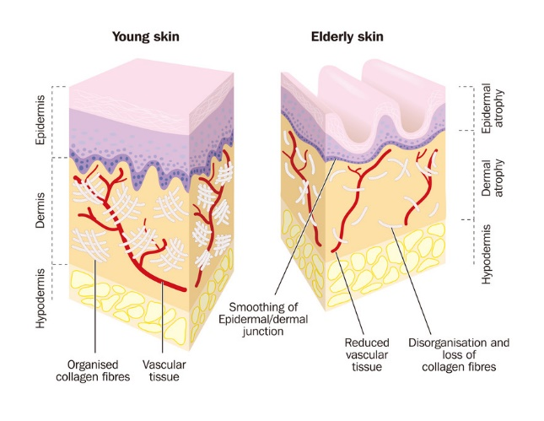
(Image courtesy of biochem.com)

Type 1 hydroxyapatite
These are naturally occurring mineral that is formed from calcium and the apatite. The chemical formula is Ca5 (Po4)3(OH). Hydroxyapatite is synthesized using different distinguished methods right from the wet chemical deposition to the biometric deposition. Hydroxyapatite is found in the teeth and the bones of the human being; they exist as a coat that helps the bone to outgrow and form several implants.
There are similar makeups that are identical in the teeth and bone, but the synthesis is different depending on the skeleton (Li, 2014). With a high temperature, the bones are transformed into porous substances that allow the movement and rapid growth of the molecules including proteins and other molecules that help in strengthening the teeth. Additionally, the molecules are responsible for preventing the immunity response and hence useful in the body. The diagram below shows part of the Hydroxyapatite.
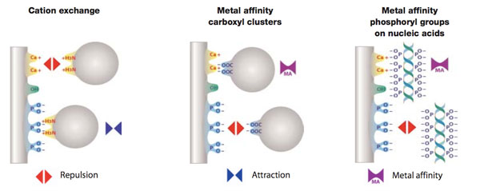
(Image courtesy of biochem.com)
How collagen and hydroxyapatite are organized in bone
Bones tissues are forms a pair of about 500,000 that can be identified through the surgical process. Strong bones contain a composite of collagen and hydroxyapatite. The two components are substituted as osteoconductive. In many cases, collagen is represented in the digestive format and hence suitable for the coating underlying the teeth bone. Similarly, collagen is represented as a bead that can be analyzed through the use of collagenase digestion. The organization of collagen is a bit different as compared to that of the hydroxyapatite.
Collagen is organized in a bead format. This means that the bone that is supporting collagen must be able to adhere to the rule set by the organization. On the other hand, the hydroxyapatite is organized circularly. This means the bones are circular in nature both the normal bones and the teeth. Through the organization process of the collagen, several separations take place (Wingender, 2016)
The separation is through the isolation process of the protein level and the soluble components that are insoluble with the aim of forming well-distinguished components of the collagen. Collagen and the hydroxyapatite are isolated through the process of treating the component that is similar. With this, the two can be recovered from their original status. However, combining the two collagen and hydroxyapatite is advantageous as the solution helps in tooth and bone repair and hence the medicinal value of each of the component.

Reference list
Chapman, M., Mukund, K., Subramaniam, S., & Lieber, R. (2016). Multiple Specific Cell Types Produce Type 1 Collagen During Skeletal Muscle Fibrosis. The FASEB Journal, 30(1 Supplement), 1245-5.
Li, C., Born, A. K., Schweizer, T., Zenobi‐Wong, M., Cerruti, M., & Mezzenga, R. (2014). Amyloid‐hydroxyapatite bone biomimetic composites. Advanced Materials, 26(20), 3207-3212.
Wingender, B., Bradley, P., Saxena, N., Ruberti, J. W., & Gower, L. (2016). Biomimetic organization of collagen matrices to template bone-like microstructures. Matrix Biology, 52, 384-396.

